# Microservices architecture – Spring Cloud

## Centralized application configuration – Spring Cloud Config Server

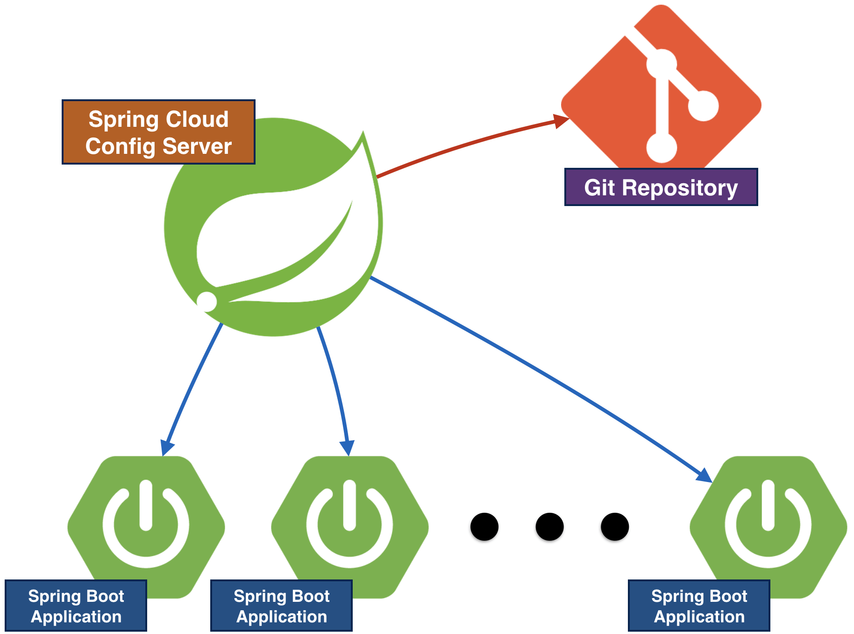 Server responsible to host all microservices configuration in one centralized repository (Git). Each microservice has its own configuration (database, business logic config or external integration configuration) also depending on the running environments (each environment could run multiple instances of the same microservices):

* A **Development environment** is where you configure, customize, and use source control to build an image of the Waveset application to be promoted to another environment. You also write an upgrade procedure in this environment that you follow in each target environment.
* A **Test environment** is where you test your upgrade procedure against controlled data and perform controlled testing of the resulting Waveset application.
* A **QA environment** is where you test your upgrade procedure against data, hardware, and software that closely simulate the Production environment and where you allow intended users to test the resulting Waveset application.
* A **Production environment** is where the Waveset application is actually available for business use.

The server is able to provide all possible configurations depending on the running environment.

